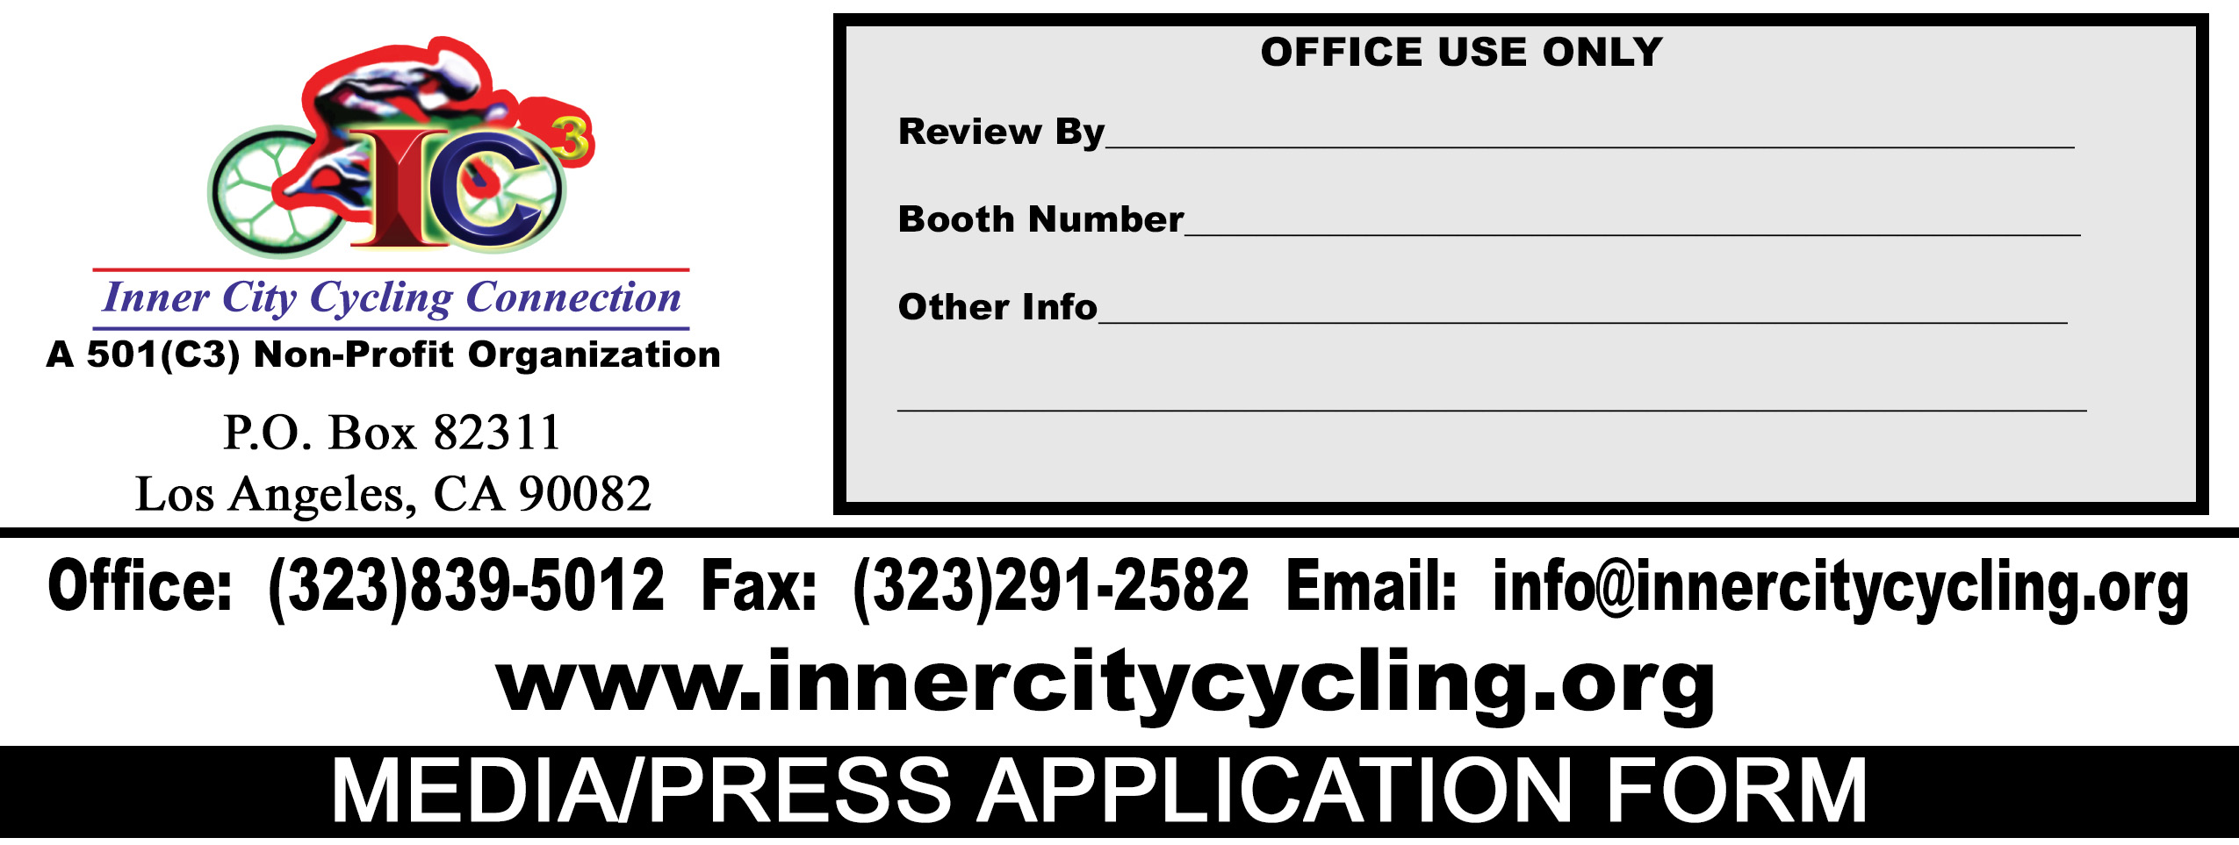
INFORMATION (Print Clearly)
Please attach a copy of your I.D. with this form. (Acceptable I.Ds: Driver’s License, Passport, Military I.D., State I.D. Card)
- Please submit this form with a copy of your I.D. at least 30 days ahead of the event to be considered. You will be notified of acceptance or rejection to cover the event at least two weeks ahead.
- If accepted to cover our event, please have your I.D. ready at the check-in and registration booth when you sign in on the day of the event.
Email form and I.D. back to info@innercitycycling.org
Company You Representing |  |  | Website:
Your Name |  |  | Cell Phone #:
Email Address |  |  | Business Phone #:
Event Name |  |  | Event Venue/Location:
Date(s) of Event |  | Last Date of Press/Media Accreditation |  | Media Type(s)
Media Type Examples: Newspaper, Television, Radio, Magazine, Alternate Newsletter, Digital Media, or Other (specify)
Other Information/Comments

****NOTICE****
I ACKNOWLEDGE THAT I, MY EMPLOYEES OR VOLUNTEERS WILL NOT BE COVERED UNDER ANY OF THE SPONSOR LIABILITY INSURANCE FOR ANY INJURY INCURRED OR CAUSE AS A RESULT OF MY PARTICIPATION IN THE ABOVE MENTIONED EVENT/ACTIVITY BUT WOULD BE RESPONSIBLE THROUGH PERSONAL INSURANCE FOR ANY AND ALL MEDICAL EXPENSES INCURRED AS A RESULT OF INJURIES FROM THIS PARTICIPATION.

I UNDERSTAND I AM COMPLETELY RESPONSIBLE FOR ALL LIABILITIES, DAMAGES, AND INJURIES I, MY EMPLOYEES, MY VOLUNTEERS OR MY PARTICIPANTS MAY CAUSE TO INNER CITY CYCLING CONNECTION, INC. & ITS ASSOCIATES, ITS MEMBERS, EMPLOYEES, AND ALL THIRD PARTIES (E.G.: SPECTATORS, BUYERS, ETC.) AS PART OF MY PARTICIPATION IN THIS EVENT INCLUDING DAMAGES OR INJURIES CAUSE BY MY EQUIPMENT, DISPLAYS, VEHICLES, AND SUPPLIES AND INCLUDING ANY AND ALL INJURIES OF ILLNESS MY PARTICIPATION MAY CAUSE.

I HAVE READ ALL THE TERMS AND CONDITIONS SET FORTH IN THIS CONTRACT AND UNDERSTAND THEM FULLY.

Applicant Signature________________________________________________________________________________________DATE______________________

